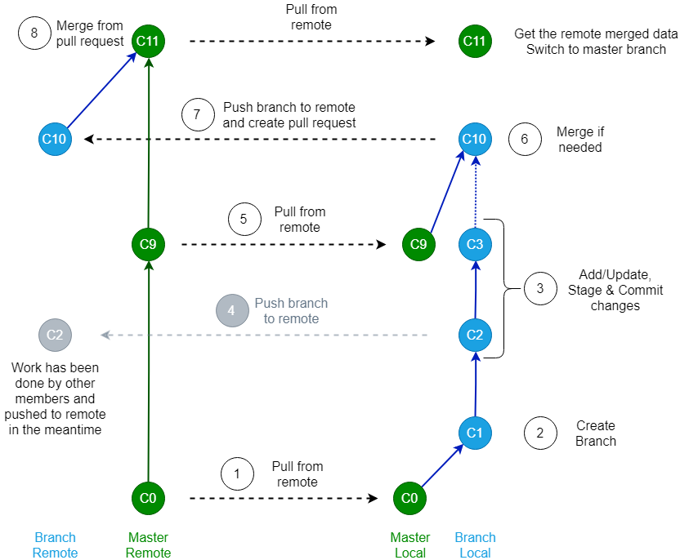

Figur 1: Git Workflow for BAC_IWAMS

The steps in the workflow figure are explained more detailed as following:

1. Checkout master on local and pull from remote
2. Create branch and checkout.
   1. Make sure the branch name is very descriptive of the work to be done!!!
3. Update/Add, Stage and Commit changes to the branch.
4. (Optional) Branch can be pushed to remote during work process.
   1. Enables team members to view the branch progress
   2. Good if two or more members are working within together within the branch.
5. When work is completed, checkout to master remote and pull from server.
6. Merge master local into your branch local.
7. Push local branch to remote & create pull request.
8. Your team member has finished the review, and merged your branch into the master branch.
   1. Your branch should now be closed.
   2. Pull from remote to get merged data and switch to master branch.